Day 2: Device to Cloud

* Temperature
* Light
* Physical sensors
* Ultrasonic
* Sound
* Hardware for IoT
* Device anatomy
* Arduino IDE primer
* Sketch Language primer
* Programing and debugging
* Getting data from Sensors

Hardware for IoT

* Prototyping platform
* IoT Starter Kit
* Sensors
* IoT Connectivity
* Loy’s IoT Starter Kit

Prototyping platform

* Arduino
* Raspberry Pi
* Intel Edison
* Beagle Board
* NodeMCU (ESP8266)

Arduino

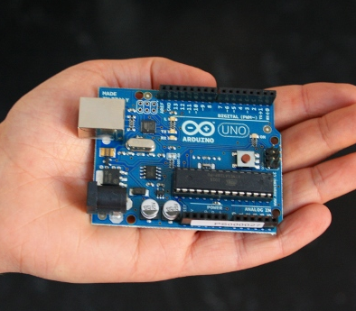 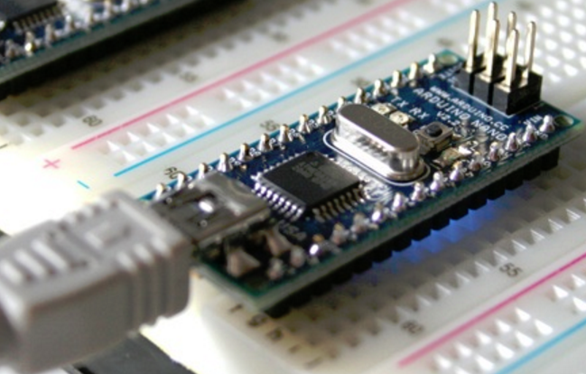

Arduino Uno Arduino Nano

* Micro-controller: ATMEGA
* Open Source
* Developed in Italy
* Language: Arduino sketch

Raspberry Pi

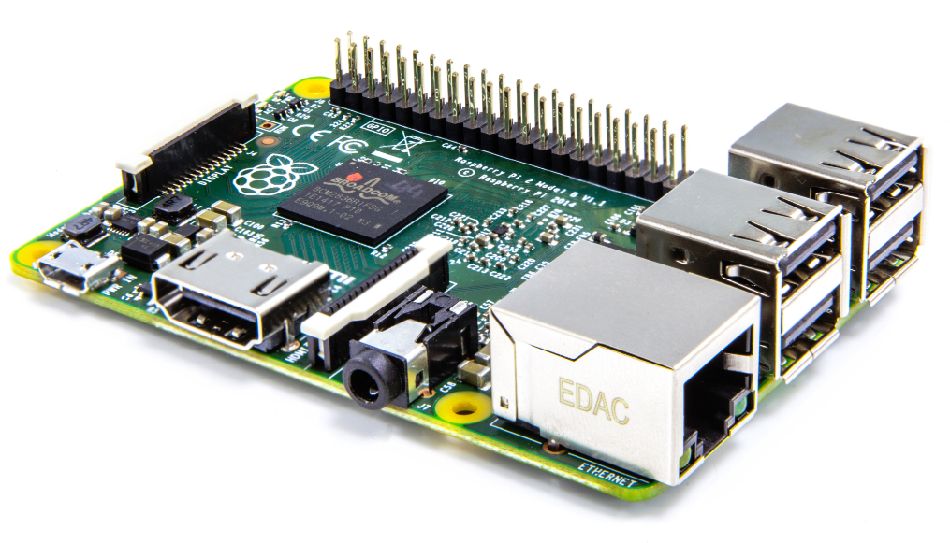

* Micro-controller: ARM Cortex
* Close Source
* Developed in UK
* Language: Java

Intel Edison

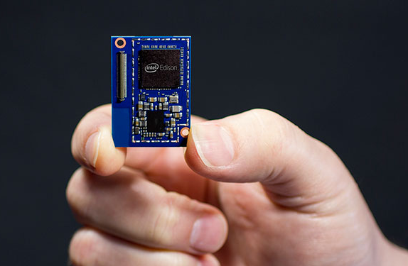

* Micro-controller: Intel Atom 2-Core
* Close Source
* Developed in USA
* Language: C / C++

Beagle Board

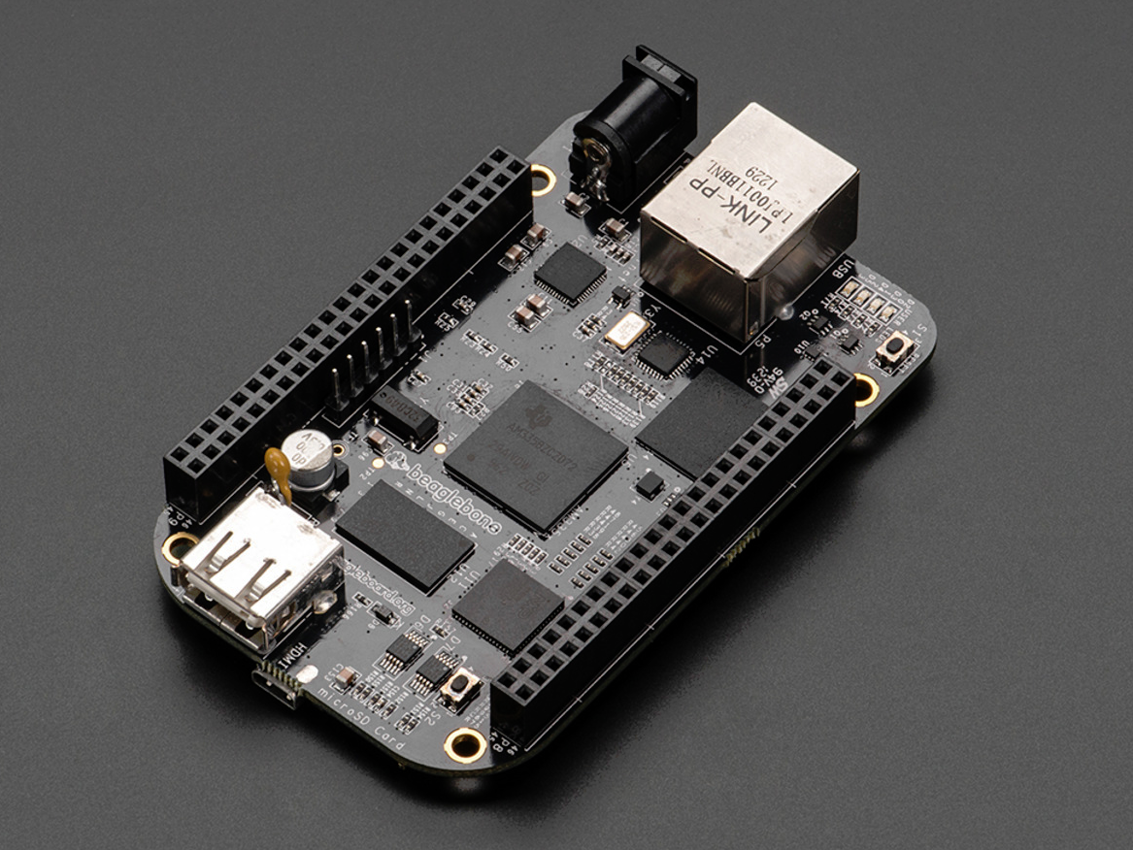 BeagleBone Black

* Micro-controller: ARM Cortex
* Open Source
* Developed in USA
* Language: Java

IoT Starter Kit

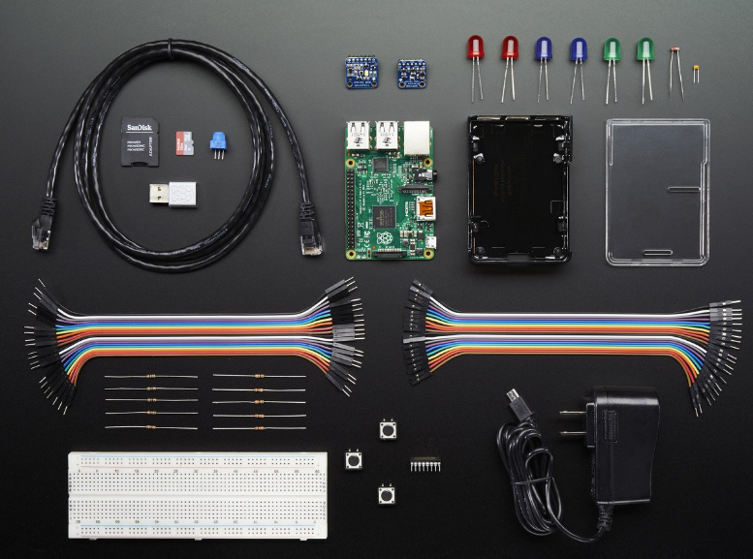 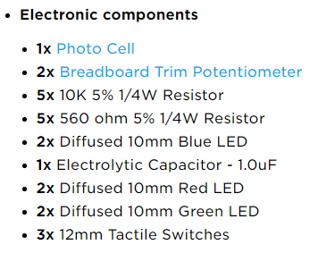

Adafruit Feather board: Raspberry Pi

Grove Starter Kit for Arduino

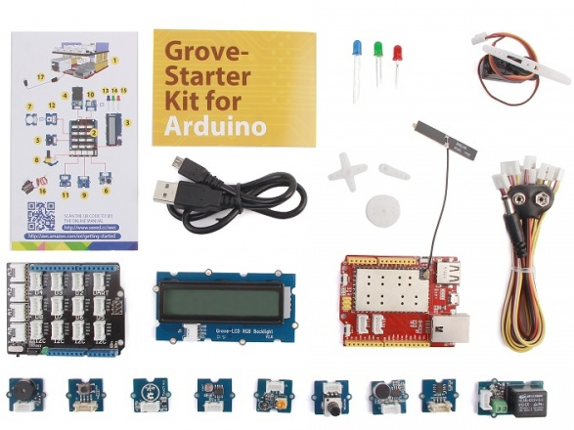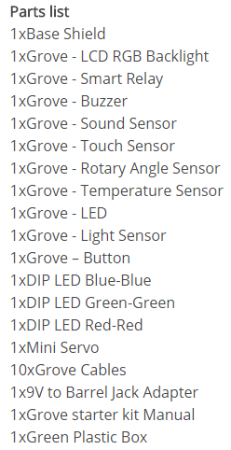



Smart Living Starter Kit for Intel Edison

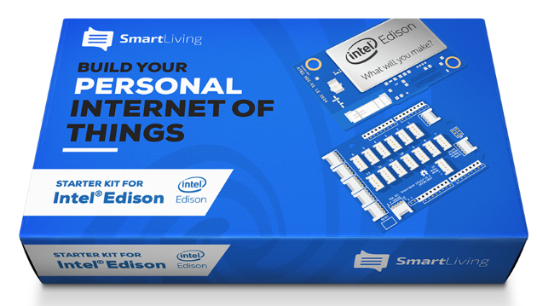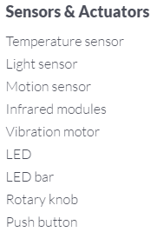



BeagleBone Green IOT for AWS

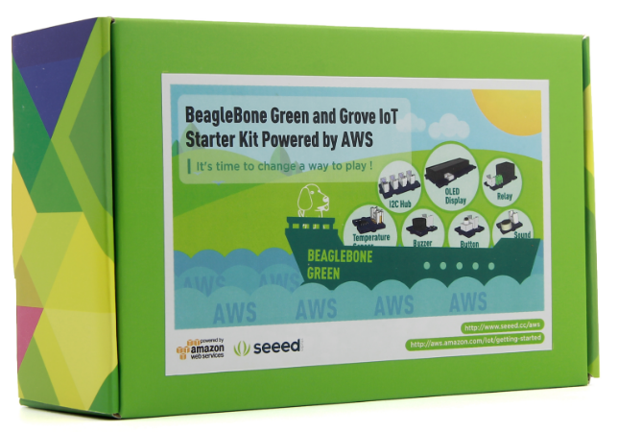 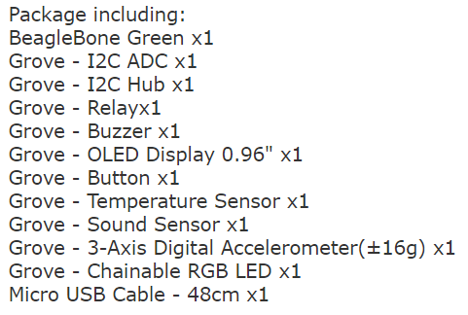

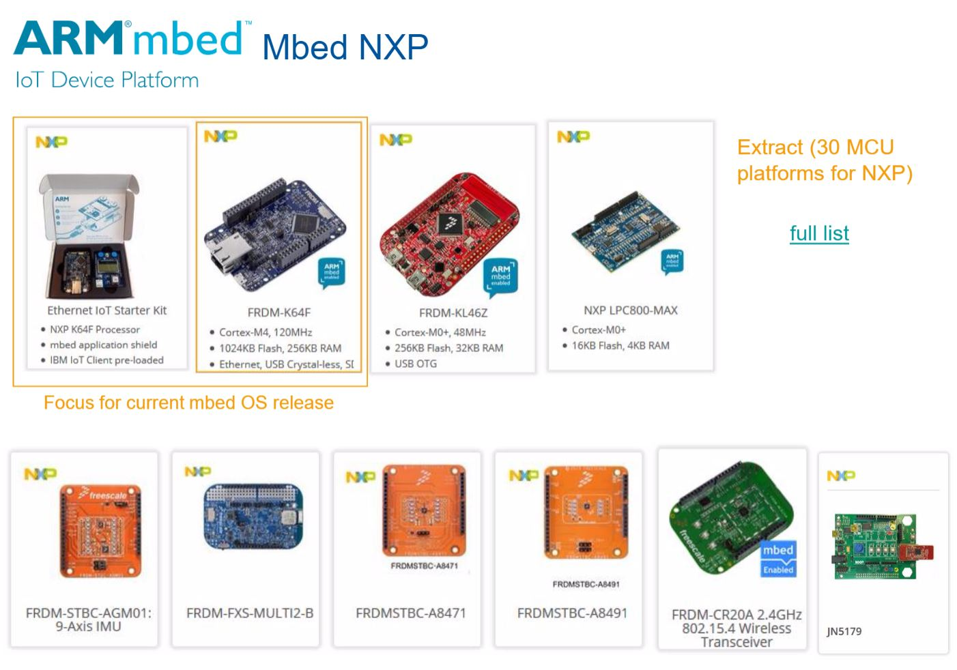

NodeMCU

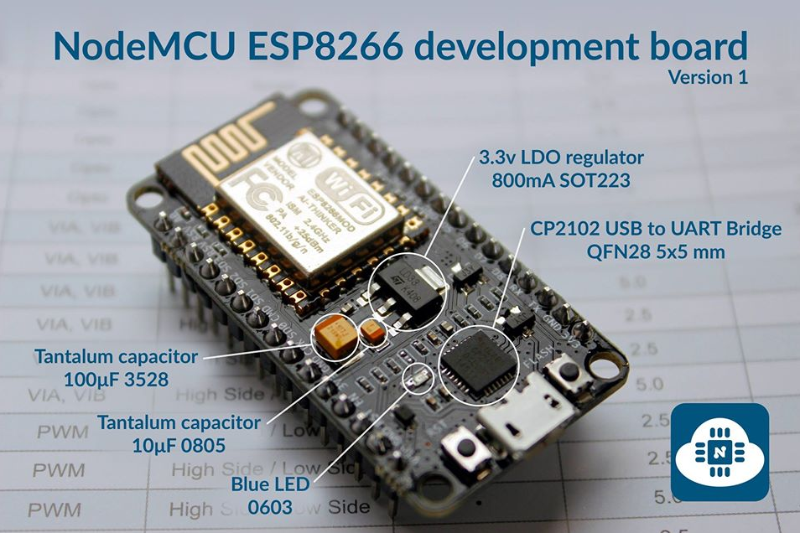

BOSCH XDK

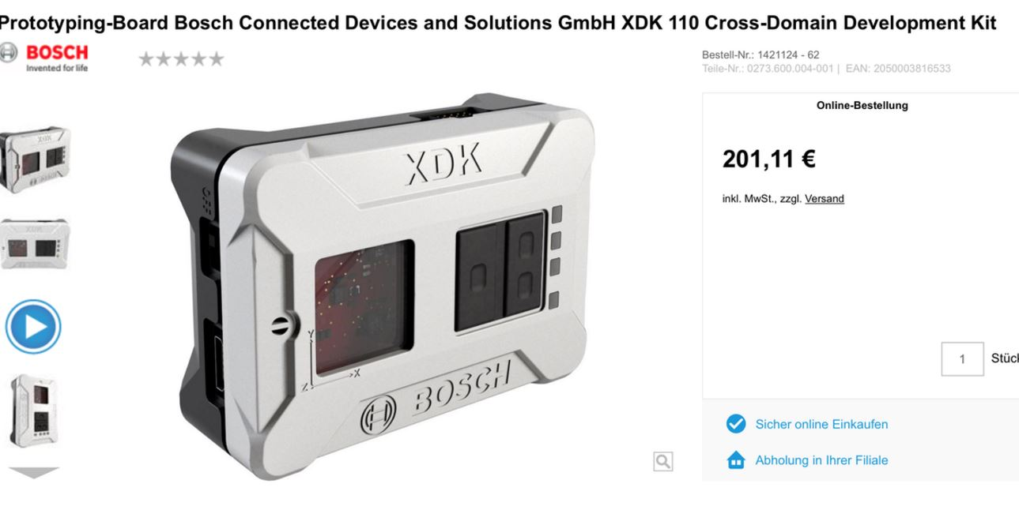

More On IoT Hardware

* Microsoft Azure IoT Starter Kits

https://azure.microsoft.com/en-us/develop/iot/starter-kits/

* EBV Elektronik NXP IoT Berlin Presentations

https://www.dropbox.com/sh/iqo7d7906khrt5v/AAC0bZy2IY6Ekp8QUQ8zo0bla?dl=0

Sensors

* Acoustic, sound, vibration
* Automotive, transportation
* Chemical
* Electric current, electric potential, magnetic, radio
* Flow, fluid velocity
* Ionizing radiation, subatomic particles
* Navigation instruments
* Position, angle, displacement, distance, speed, acceleration
* Optical, light, imaging, photon
* Pressure
* Force, density, level
* Thermal, heat, temperature
* Proximity, presence

Motion Sensor

https://www.sparkfun.com/products/13285

Description: This is a simple to use motion sensor. Power it up and wait 1-2 seconds for the sensor to get a snapshot of the still room. If anything moves after that period, the ‘alarm’ pin will go low.

This unit works great from 5 to 12V (datasheet shows 12V). You can also install a jumper wire past the 5V regulator on board to make this unit work at 3.3V. Sensor uses 1.6mA@3.3V.

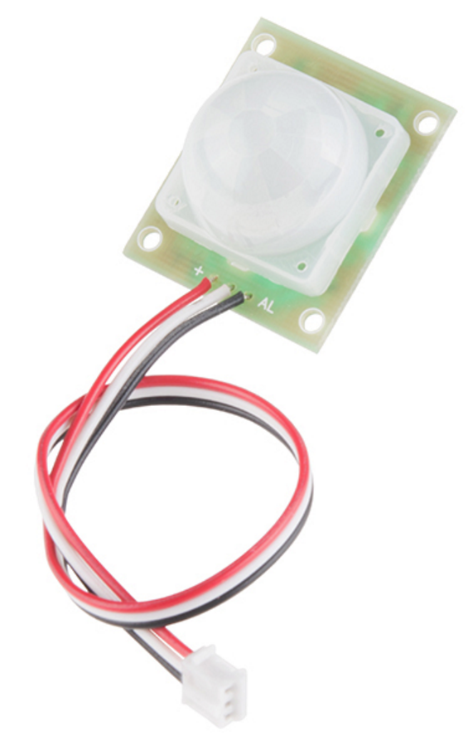

Altitude/Pressure Sensor

https://www.sparkfun.com/products/13754

Description: The MPL3115A2 is a MEMS pressure sensor that provides Altitude data to within 30cm (with oversampling enabled).

The sensor outputs are digitized by a high resolution 24-bit ADC and transmitted over I2C, meaning it’s easy to interface with most controllers.

Pressure output can be resolved with output in fractions of a Pascal, and Altitude can be resolved in fractions of a meter. The device also provides 12-bit temperature measurements in degrees Celsius.

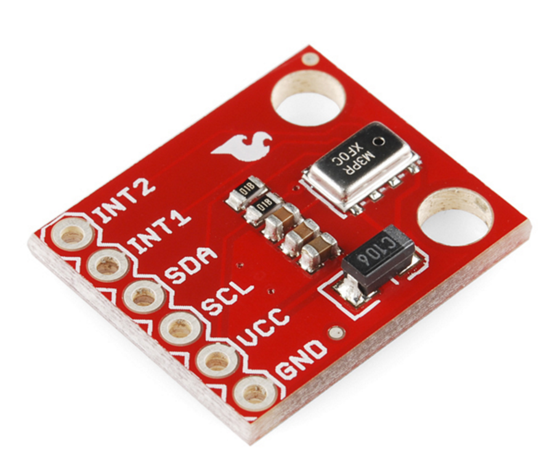

Photocell

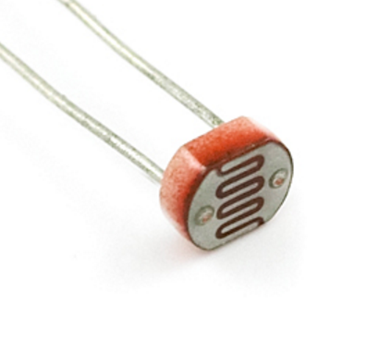

Description: The photocell will vary its resistance based on how much light it’s exposed to. Will vary from 1kΩ in the light to 10kΩ in the dark.

Humidity and Temperature Sensor Breakout - Si7021

https://www.sparkfun.com/products/13763

Description: The Si7021 is a low-cost, easy-to-use, highly accurate, digital humidity and temperature sensor.

This sensor is ideal for environmental sensing and data logging and perfect for build a weather stations or humidor control system.

All you need are two lines for I2C communication, and you’ll have relative humidity readings and very accurate temperature readings as a bonus!

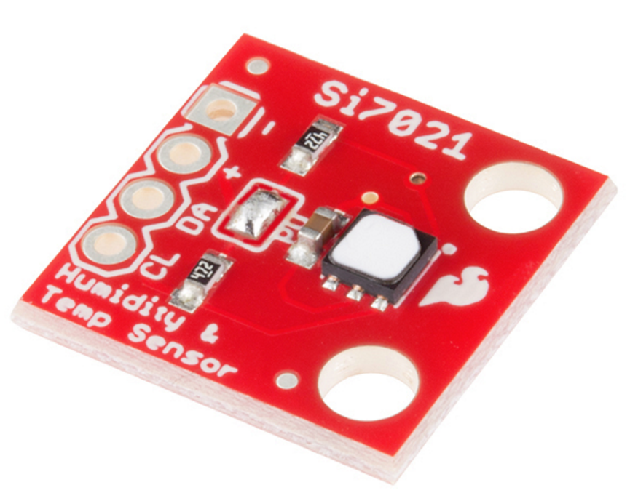

Soil Moisture Sensor

https://www.sparkfun.com/products/13322

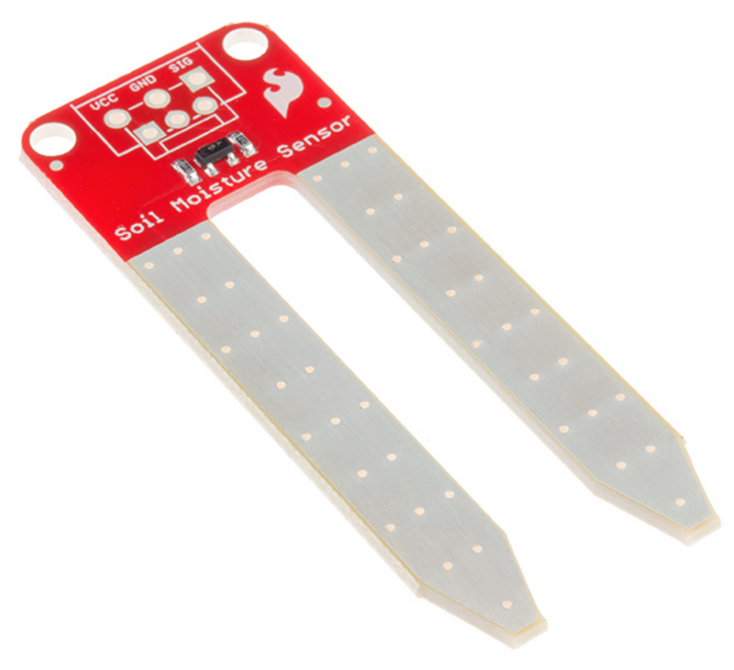

Description: The two large exposed pads function as probes for the sensor, together acting as a variable resistor.

The more water that is in the soil means the better the conductivity between the pads will be and will result in a lower resistance, and a higher SIG out.

Tri-Axis Gyro

https://www.sparkfun.com/products/10612

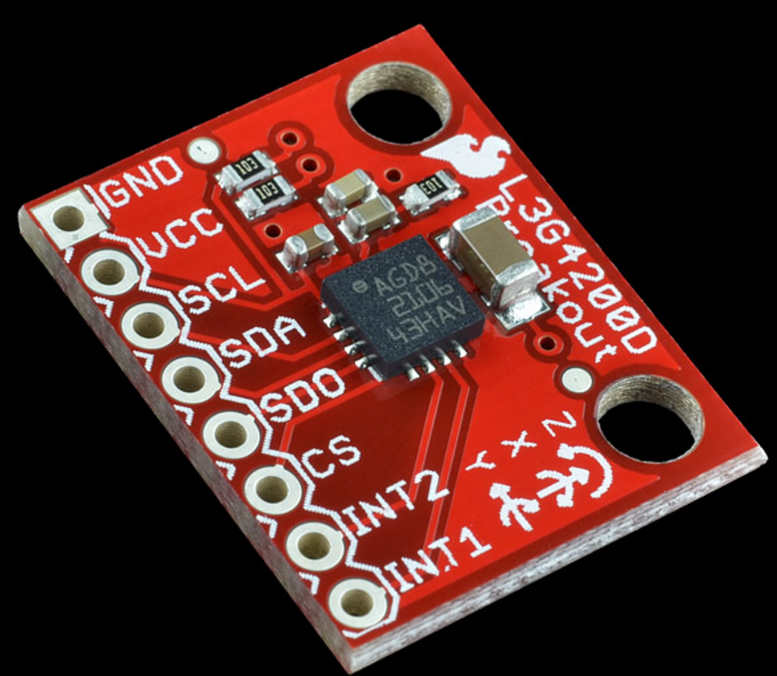

Description: Angular velocity is the change in rotational angle per unit of time. Angular velocity is generally expressed in deg/s (degrees per second).

These work great in gaming and virtual reality input devices, GPS navigation systems and robotics.

Servo Motor

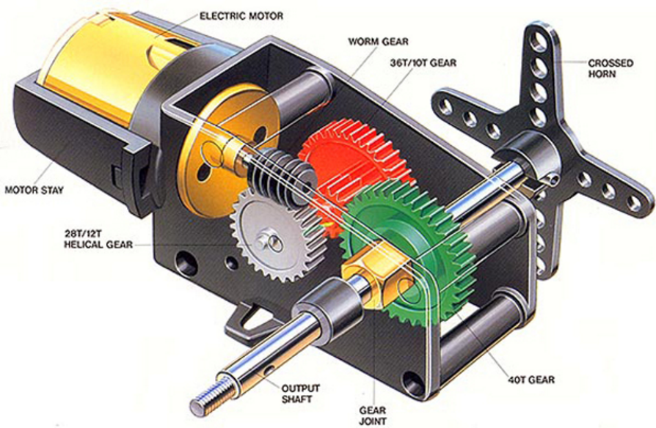

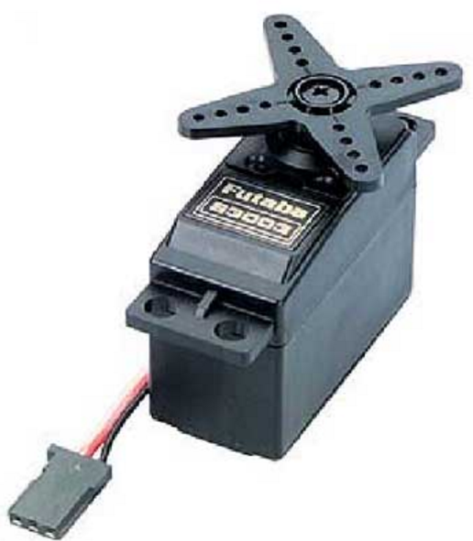

Robot Arm

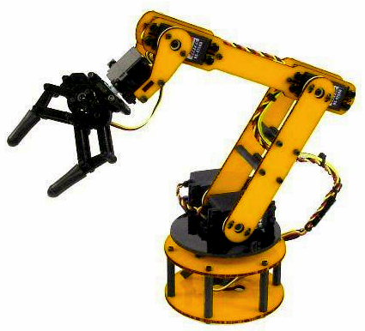

DC gear motor

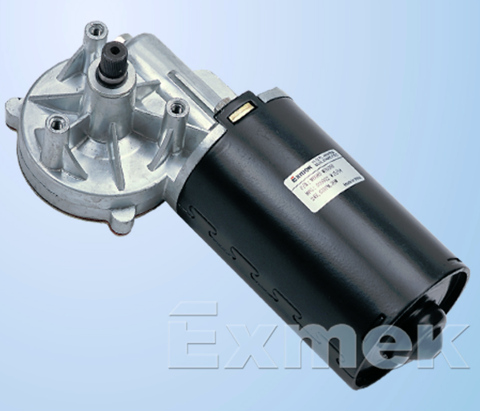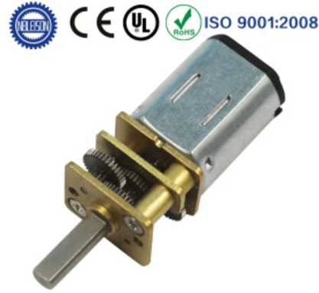

Solenoid

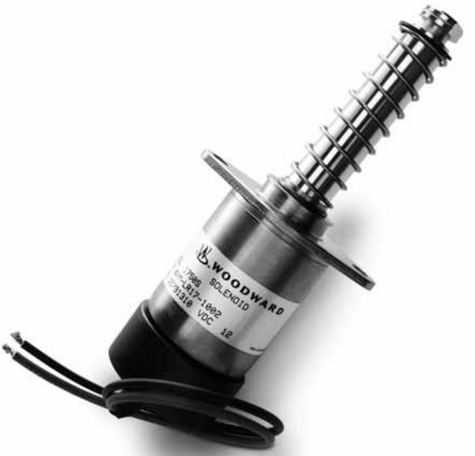

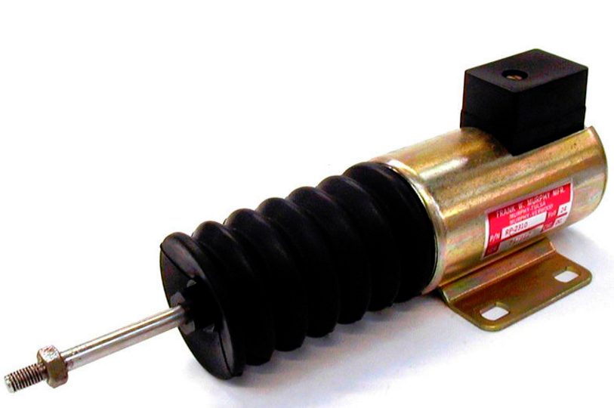

IoT Connectivity

* PAN: Personal Area Network
* 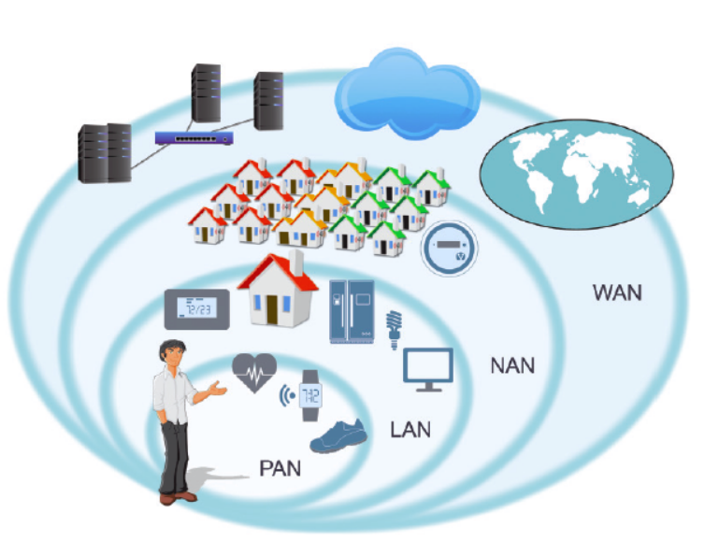LAN: Local Area Network
* NAN: Neighbourhood Area Network
* WAN: Wide Area Network



* Bluetooth low energy (BLE)
* applications in the healthcare, fitness, beacons, security, and home entertainment industries.
* Reduced power consumption and cost while maintaining a similar communication range.
* Mobile operating systems including iOS, Android, Windows Phone and BlackBerry, as well as OS X, Linux, and Windows 8, natively support Bluetooth Smart.
* 2018 more than 90 percent of Bluetooth-enabled smartphones will support Bluetooth Smart.



* ZigBee is an IEEE 802.15.4-based specification
* Used to create personal area networks with small, low-power digital radios.
* Intended to be simpler and less expensive than Bluetooth or Wi-Fi.
* Short-range low-rate wireless data transfer.
* Applications include wireless light switches, traffic management systems, and other consumer and industrial equipment



* 6LoWPAN is an acronym of IPv6 over Low power Wireless Personal Area Networks.
* Concept originated from the idea that "the Internet Protocol could and should be applied even to the smallest devices," and that low-power devices with limited processing capabilities should be able to participate in the Internet of Things.
* Allow IPv6 packets to be sent and received over IEEE 802.15.4 based networks.



* French company
* Wireless networks to connect low-energy objects
* Electricity meters, smartwatches, and washing machines
* Continuously on and emitting small amounts of data.
* $1 per device per year
* First and only company providing global cellular connectivity for the Internet of Things"
* Infrastructure is "completely independent of existing networks, such as telecommunications networks."

Wireless connectivity for IoT

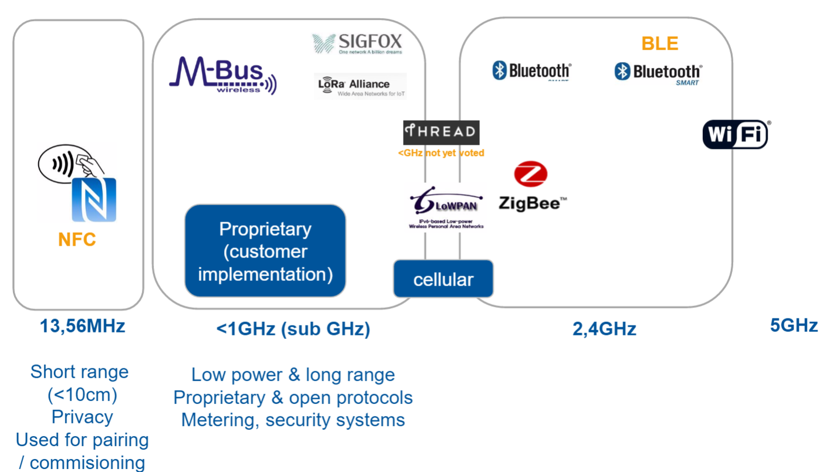

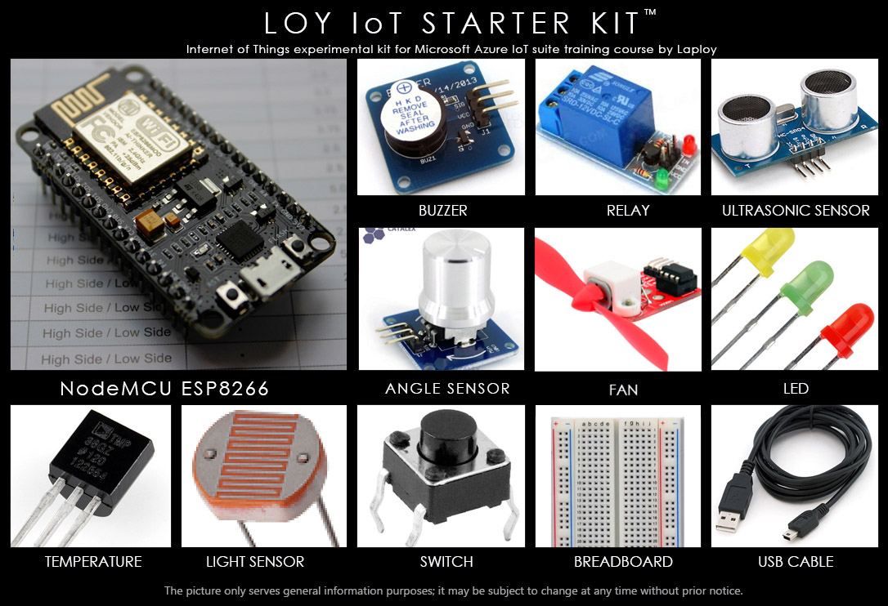

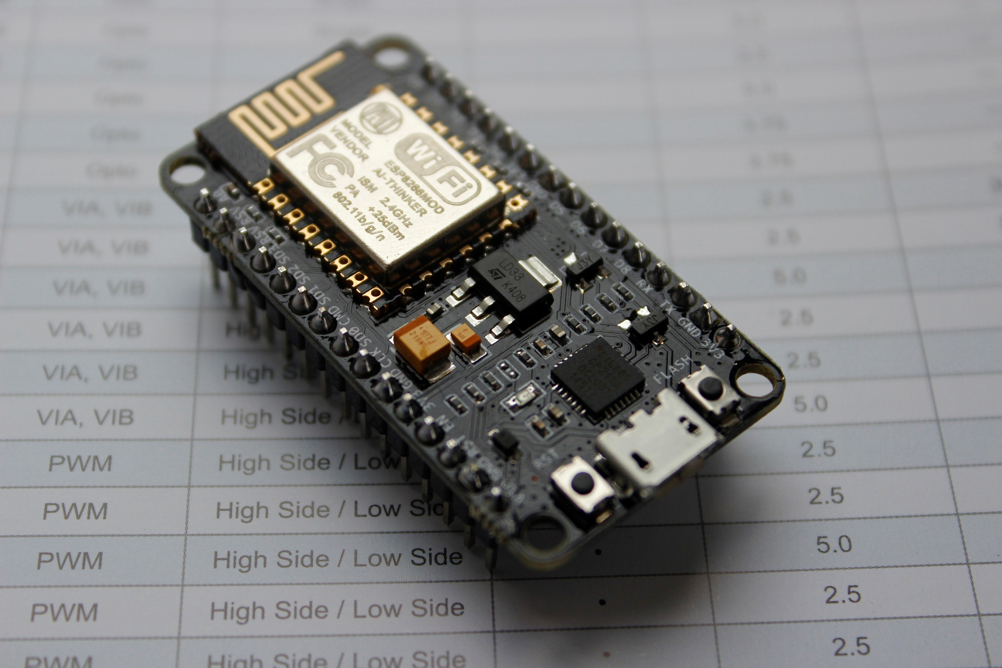

**NodeMCU ESP8266**

* **Arduino platform**
* **Have all Arduino standard feature**
* **Wi-Fi capability**
* **Rapid prototype development**
* **Highly available**
* **Low cost**
* **Small form factor**
* **USB programming**

Device anatomy

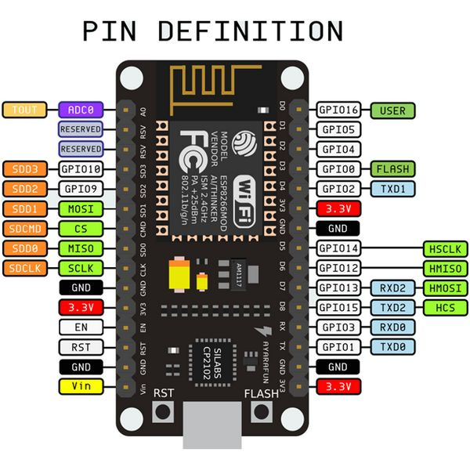

Pin description

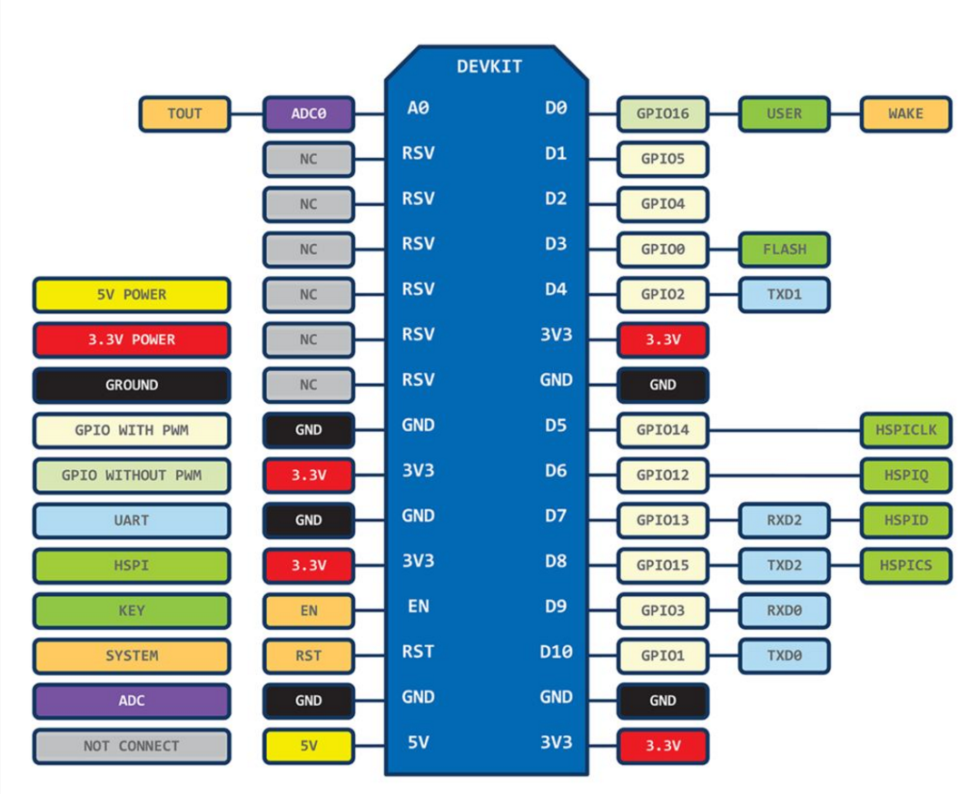

32-bit Tensilica MCU

* Tensilica L106 32-bit micro controller (MCU)
* Extra low power
* 32-bit RSIC,
* Clock speed of 160 MHz.
* Real Time Operation System (RTOS)
* Wi-Fi stack

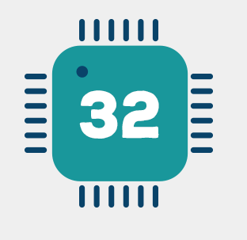

Peripheral features

* 32-bit RISC CPU: Tensilica Xtensa LX106 running at 80 MHz*
* 64 KB of instruction RAM, 96 KB of data RAM
* External QSPI flash - 512 KB to 4 MB* (up to 16 MB is supported)
* IEEE 802.11 b/g/n Wi-Fi
* Integrated TR switch, balun, LNA, power amplifier and matching network
* WEP or WPA/WPA2 authentication, or open networks
* 16 GPIO pins
* SPI, I²C,
* I²S interfaces with DMA (sharing pins with GPIO)
* UART on dedicated pins, plus a transmit-only UART can be enabled on GPIO2
* 1 10-bit ADC

PC – Arduino Cross Compile programming model

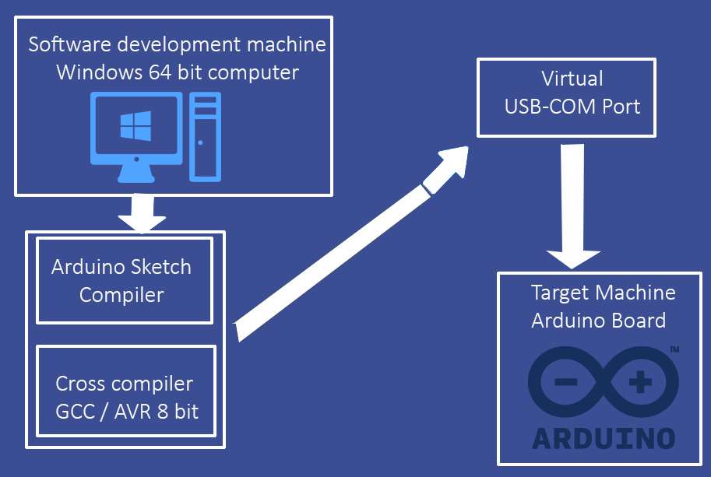

Breadboard

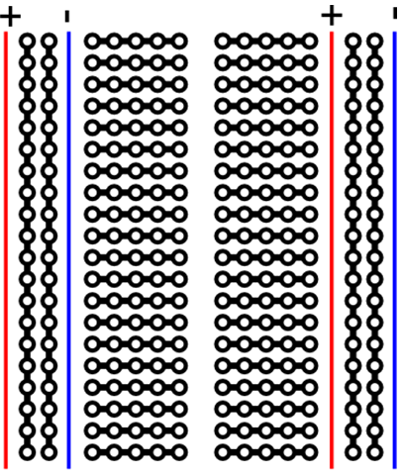

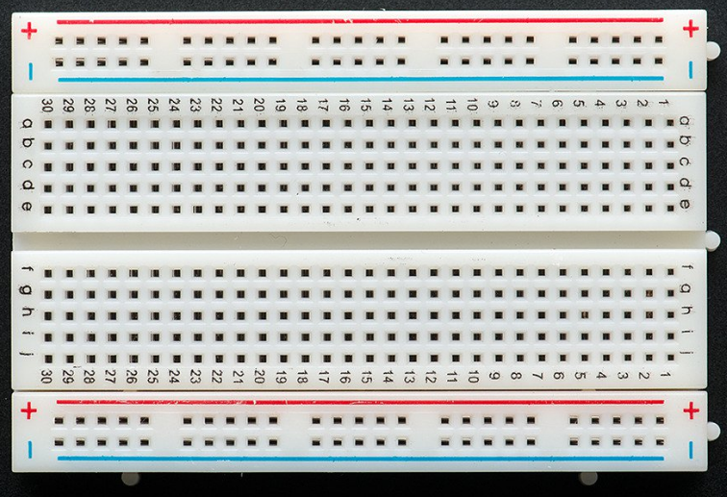

Actual Schematic

NodeMCU mounted on Breadboard

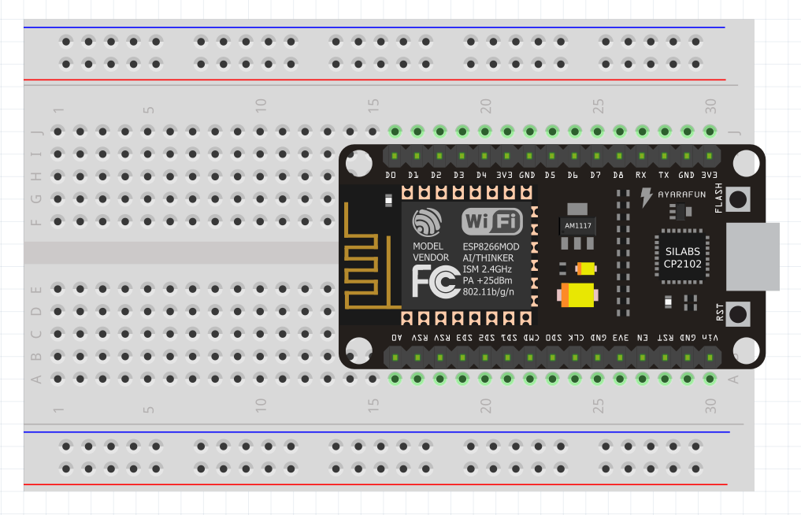

Hot Pins

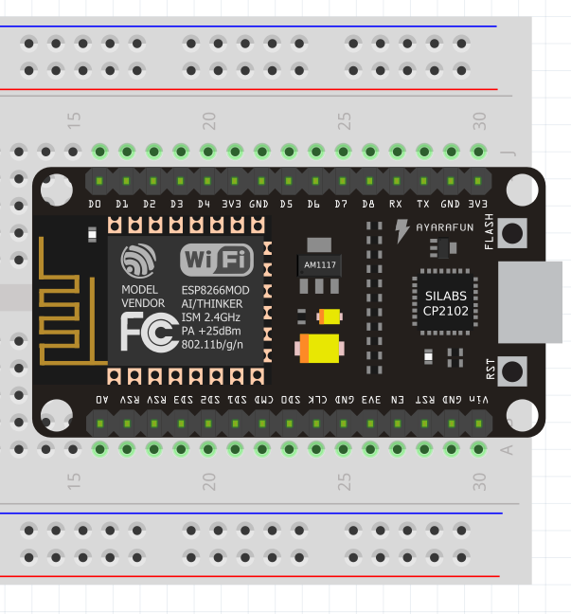



Safety Instructions

* Remove USB when not in used
* Remove USB when modify circuit
* Remove USB when hot
* Remove USB when smoke
* Do not connect hot pins to GND
* Check, re-check and cross-check before plug USB
* Immediately remove USB if no light

Powering the breadboard

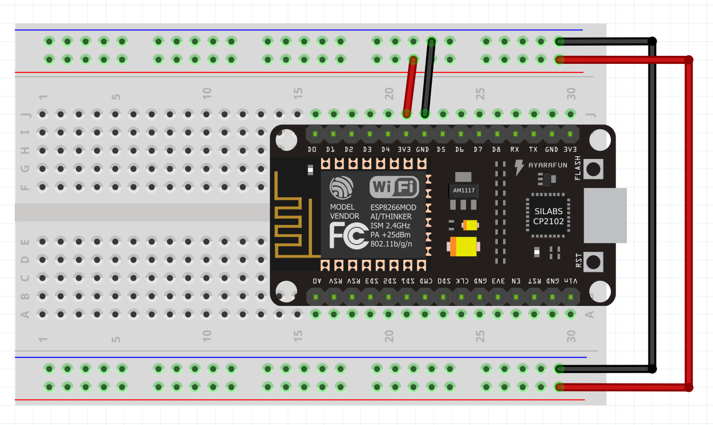

Power indicator

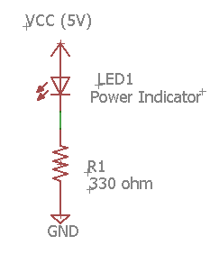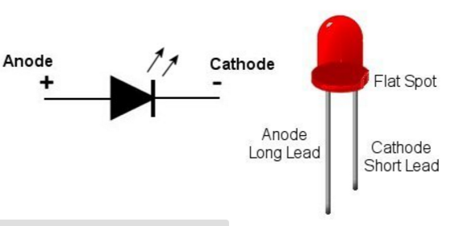

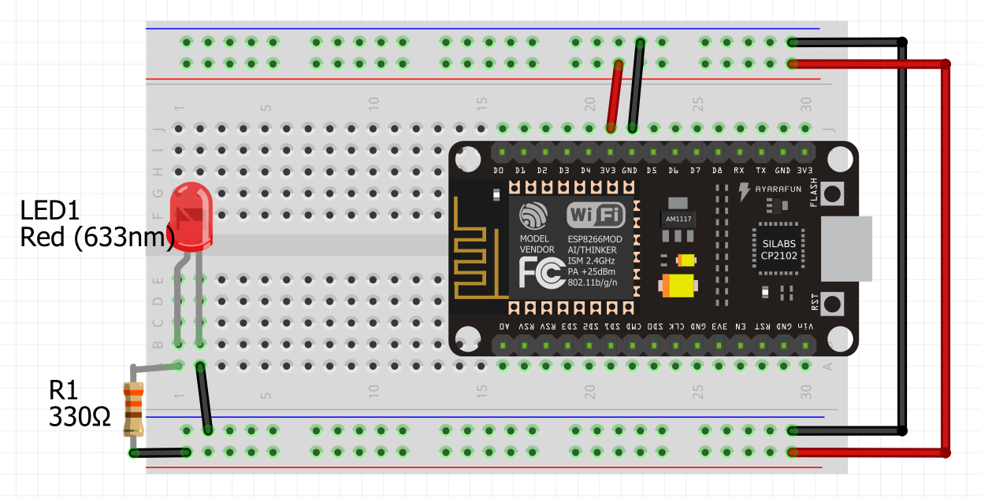

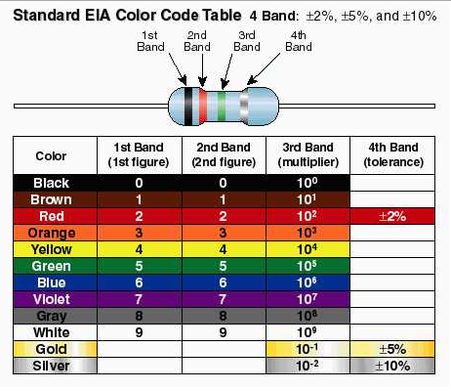

Arduino IDE primer

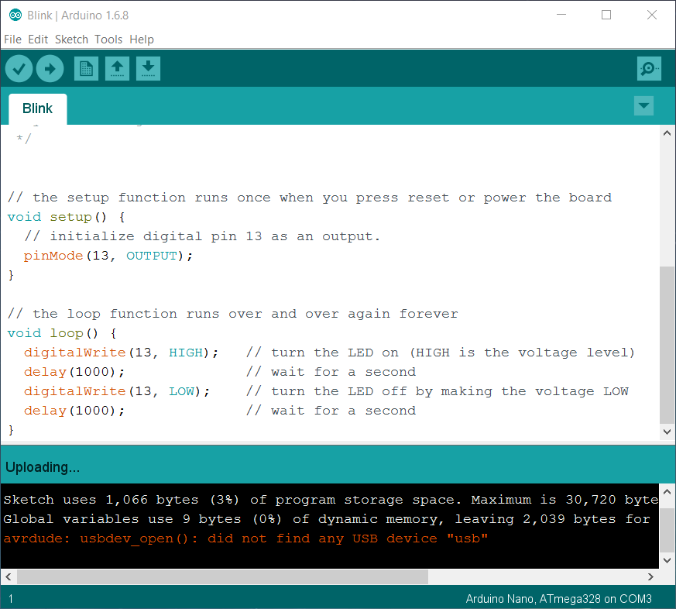

More on Arduino IDE

* Arduino Software (IDE)

https://www.arduino.cc/en/Guide/Environment

Sketch Language primer

Data type

**Datatype RAM usage**

* void keyword N/A
* boolean 1 byte
* char 1 byte
* unsigned char 1 byte
* int 2 byte
* unsigned int 2 byte
* word 2 byte
* long 4 byte
* unsigned long 4 byte
* float 4 byte
* double 4 byte
* string 1 byte + x
* array 1 byte + x
* enum N/A
* struct N/A
* pointer N/A

Variable Declaration

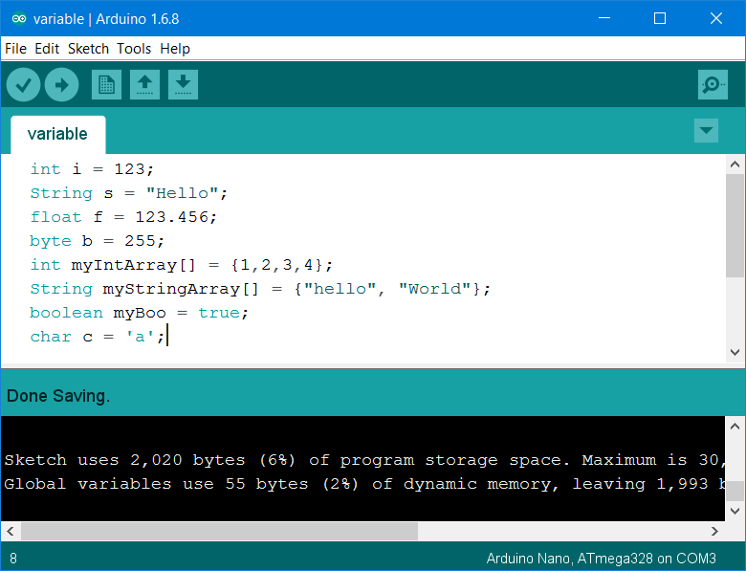

Setup and Loop

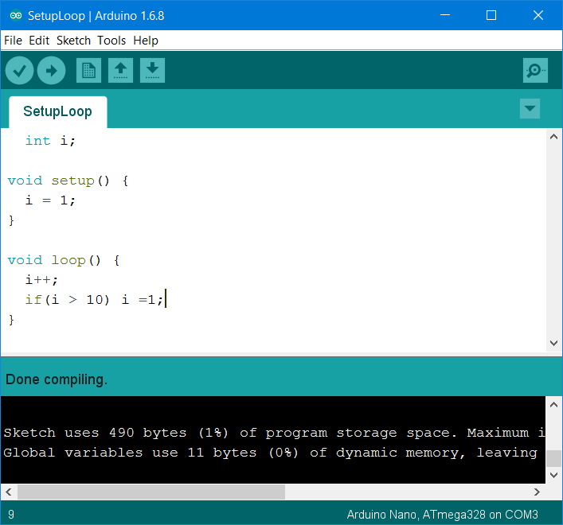

Blinky Lab

* Lab 1 Blinky: Write a program to blink an external LED
* Lab 2 BlinkyTrio: Blink 3 LEDs
* Lab3 Runner: Red LED on .5sec and off, Yellow LED on .5sec and off, Green LED on .5sec and off, repeat all over.

More on Sketch Language

* Language Reference

https://www.arduino.cc/en/Reference/HomePage

Programing and debugging

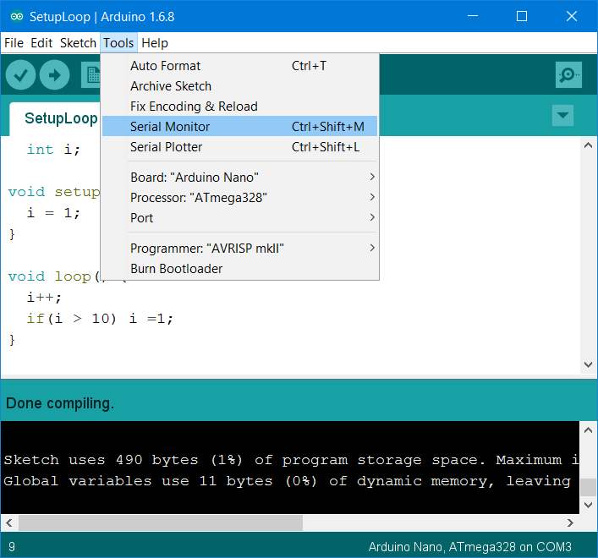

SerialHelloWorld

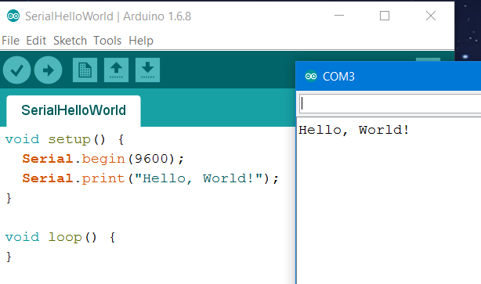

Serial Count

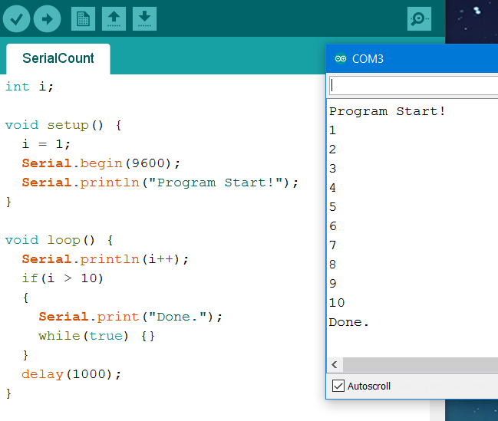

Serial.print()

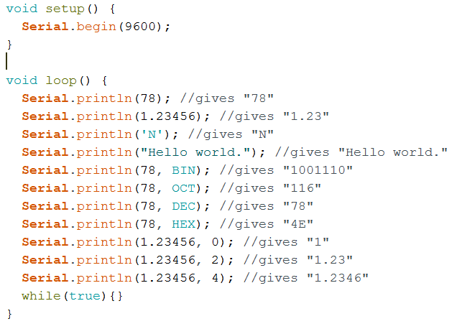

Serial Echo

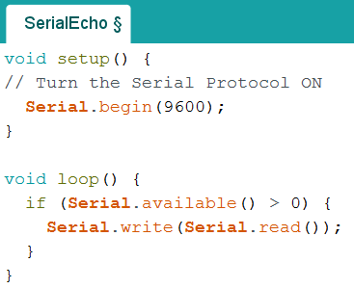

Serial Lab

* 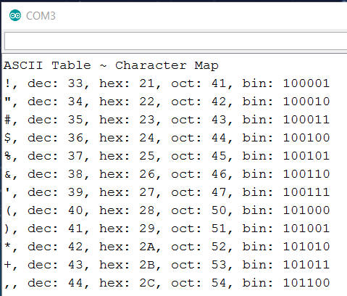Lab1: AscTable: Print out ASCII Table
* Lab2: ShowChrAsc: Get a letter from Serial input and Send out one line of ASCII information

Arduino and C#

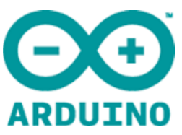 

* Arduino send message to C# Win App
* Arduino read message from C# WinApp
* Arduino execute command from C# Win App

Develop C# Win App to Read Message from Arduino

1. 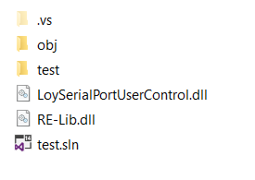Create New C# WinForm Project Copy and paste “LoySerialPortUserControl.dll” to project’s folder
2. Add Reference to files

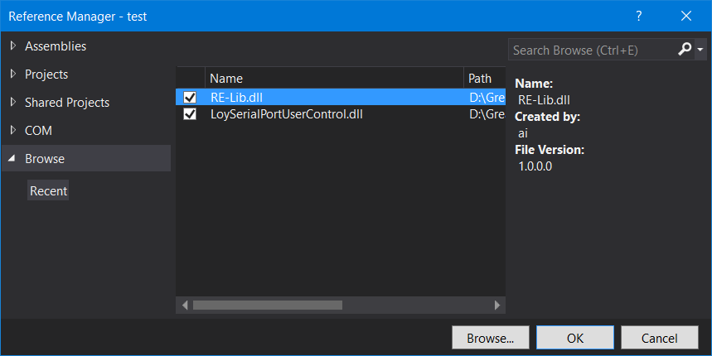

1. Add LoySerialPortUserControl.dll to Form1
2. Add TextBox to Form1. Name = TextBoxRx

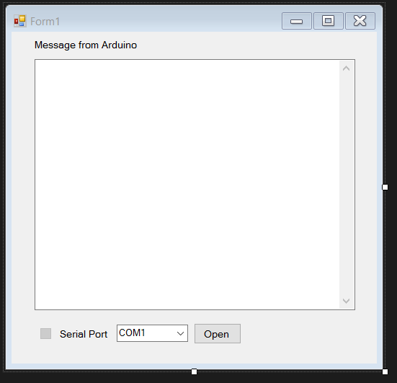

1. Add below code to Form1

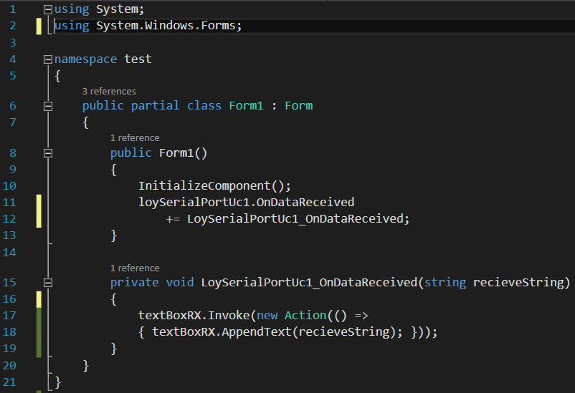

1. Test Program using Arduino AscTable code

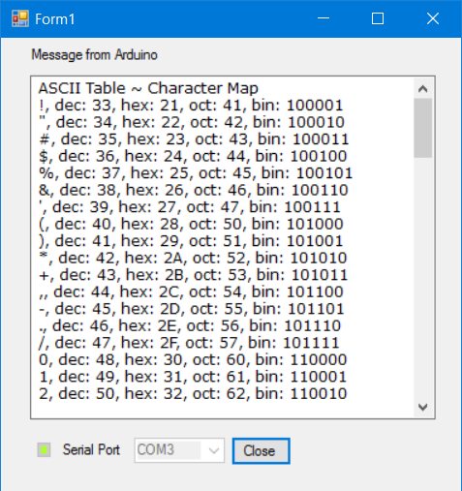

Develop C# Win App to Write Message to Arduino

1. Add a TextBox to Form1. Name = “TextBoxTx”
2. Add a button to Form1. Name = buttonSend

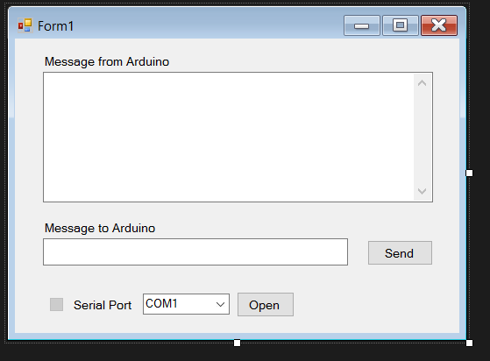

1. Add below code to Form1

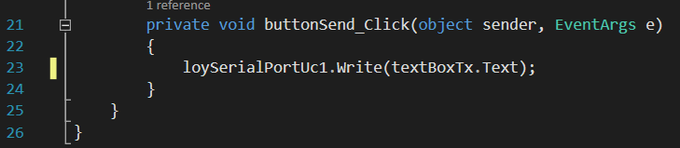

1. Test Program using Arduino SerialEcho.

Arduino <--> PC communication Lab

1. Wait for PC message
2. When receive message “turn on LED 1”, turn on LED at pin D2
3. When receive message “turn off LED 1”, turn off LED at pin D2
4. When receive message “turn on LED 2”, turn on LED at pin D3
5. When receive message “turn off LED 1”, turn off LED at pin D3

Getting data from Sensors

Temperature

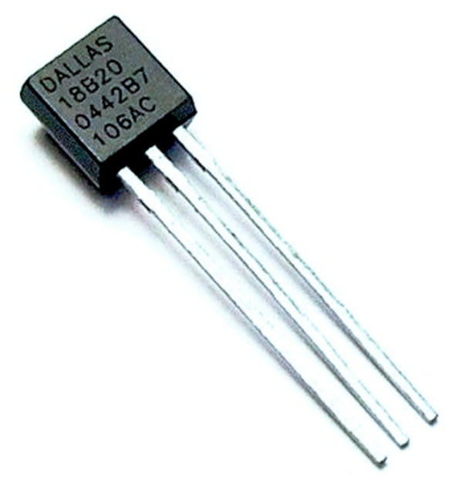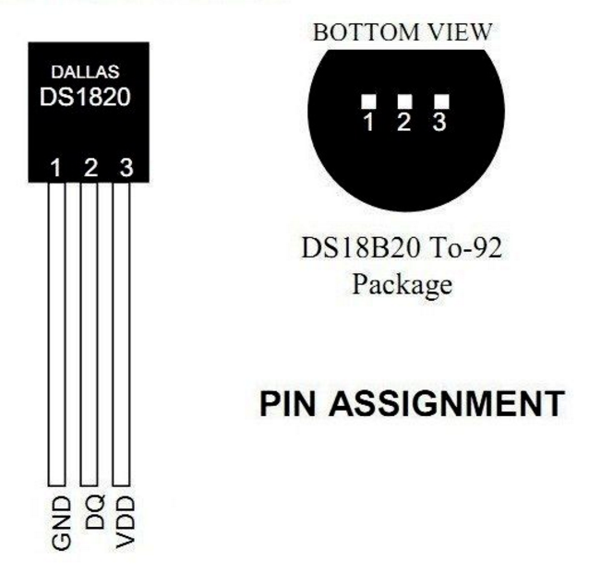

DS18B20 Programmable Resolution 1-Wire Digital Thermometer

Benefits and Features

* Unique 1-Wire® Interface Requires Only One Port Pin for Communication
* Reduce Component Count with Integrated Temperature Sensor and EEPROM
* Measures Temperatures from -55°C to +125°C (-67°F to +257°F)
* Programmable Resolution from 9 Bits to 12 Bits
* No External Components Required
* Parasitic Power Mode Requires Only 2 Pins for Operation (DQ and GND)

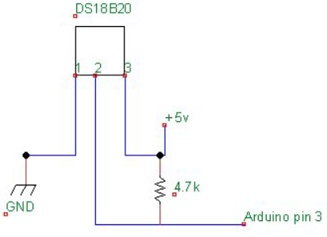

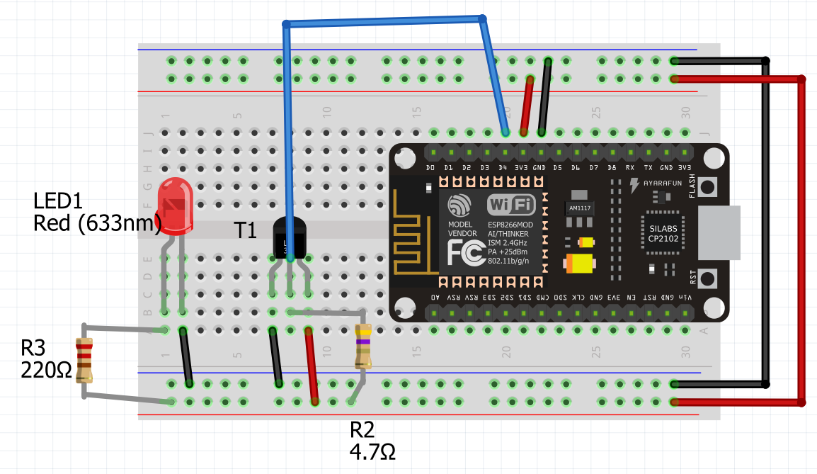

Create New Arduino Project

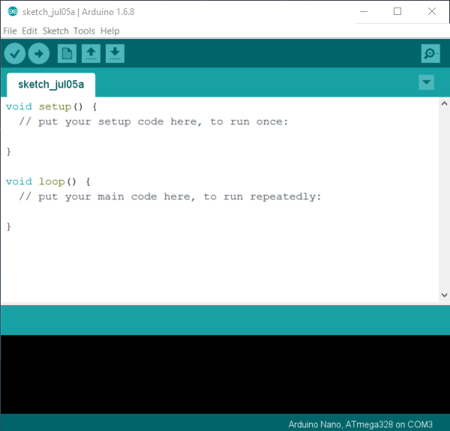

Search / Include Library / Manage Libraries…

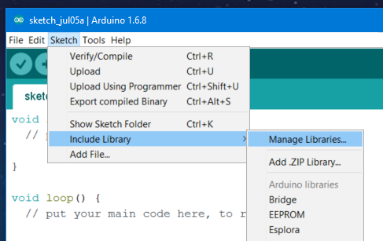

Search “one wire” / Select Version / Install

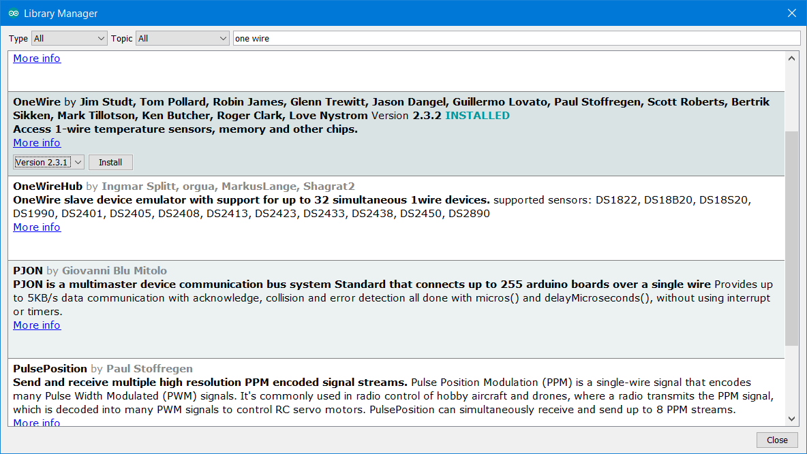

Search “DallasTemperature” / Select Version / Install

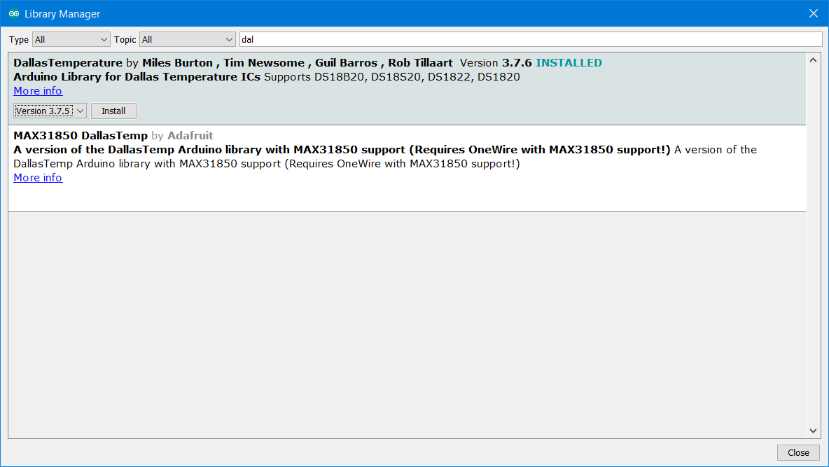

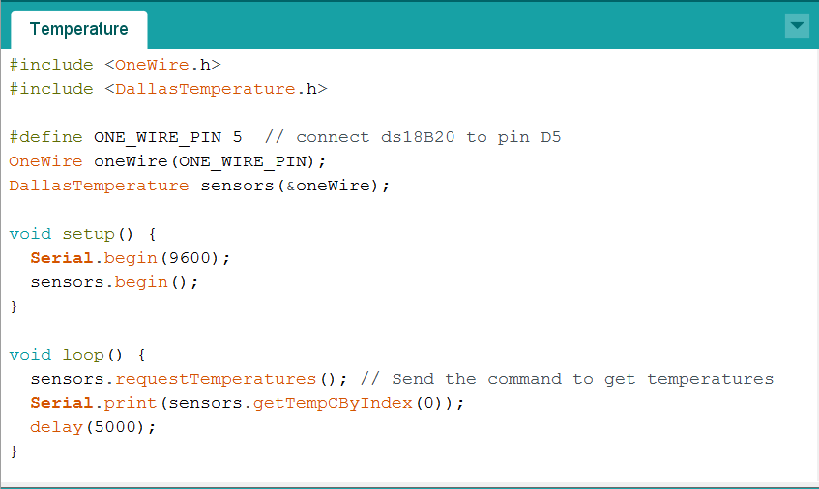

Temperature Lab

1. 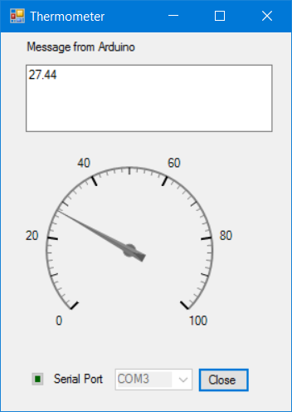Lab1: Thermometer, show temperature in WinForm with a gauge.
2. Lab2: TemClound, send temperature to Cloud.

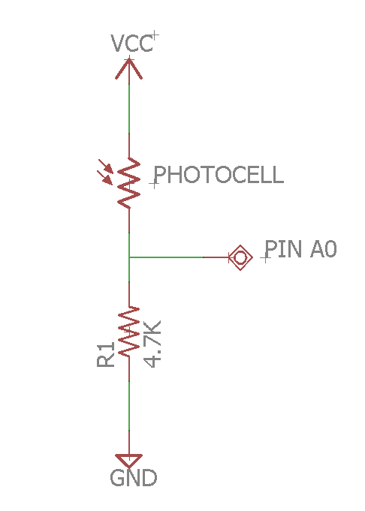Light Sensor

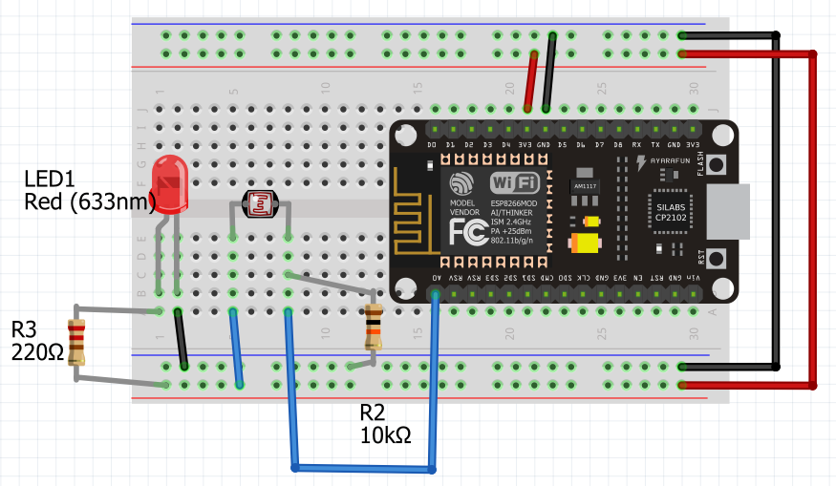

Arduino Light1

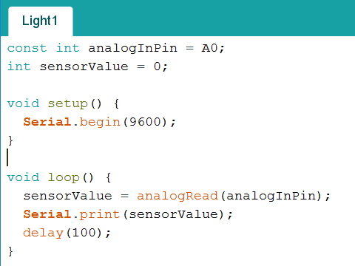

Light sensor WinForm

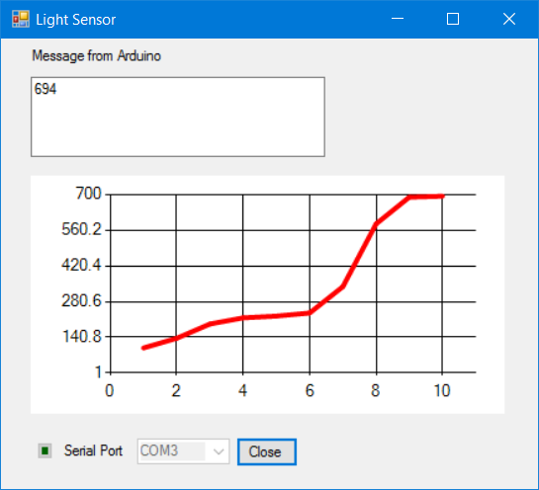

Light sensor Lab

1. Modify Light sensor WinForm to rise audio alarm if the value the beyond the specified value
2. Modify Light sensor WinForm to show other type of chart
3. Modify Light sensor WinForm to save data to log file when the value the beyond the specified value

Physical sensors

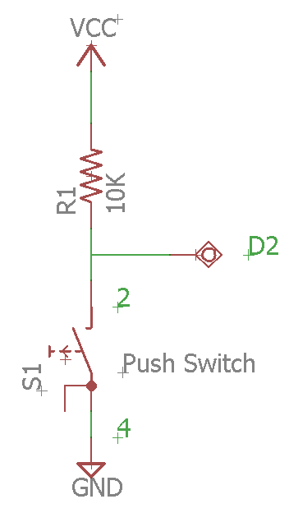

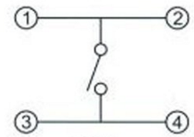

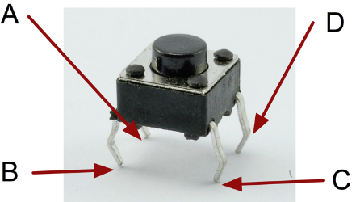

Mini Pushbutton Switch

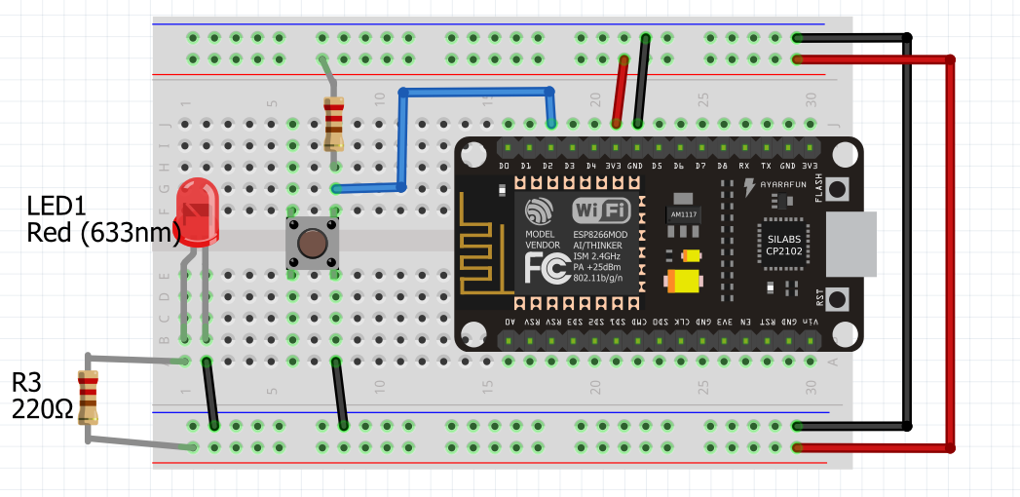

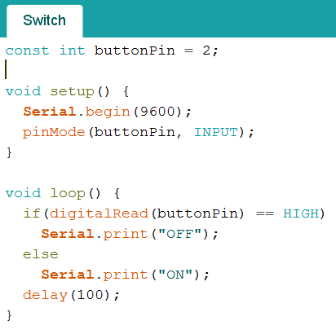

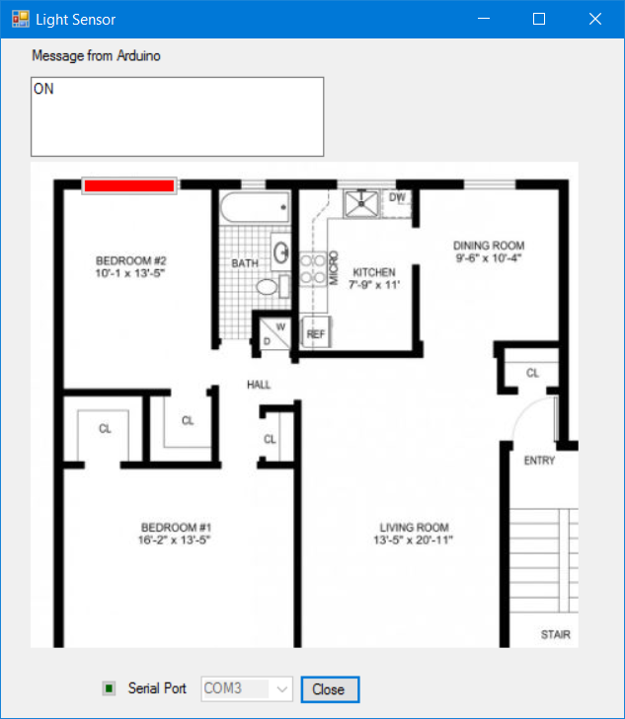

Ultrasonic

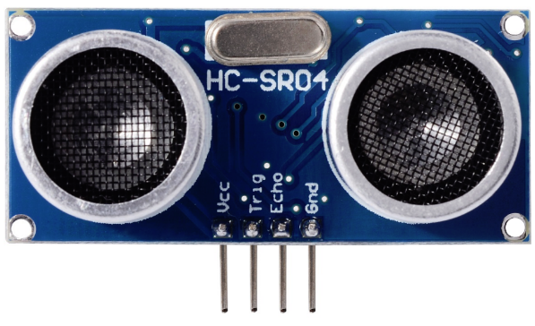

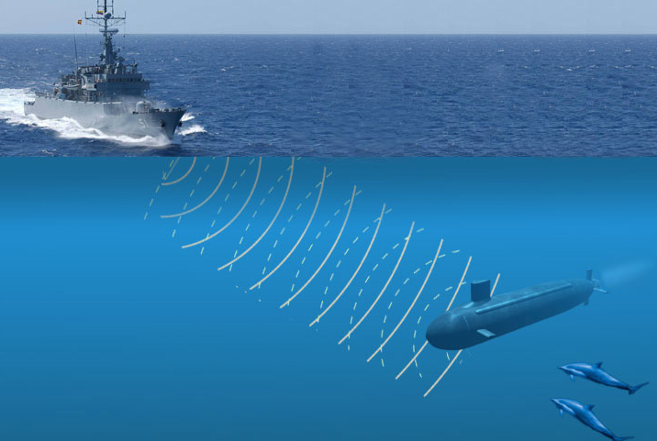

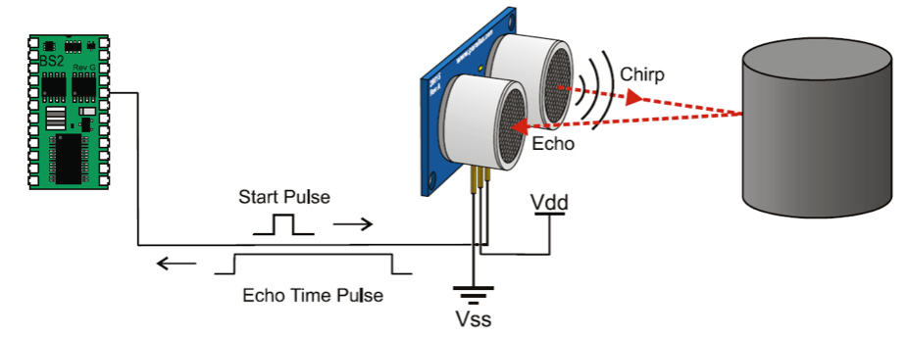

Trig D3 Echo D2

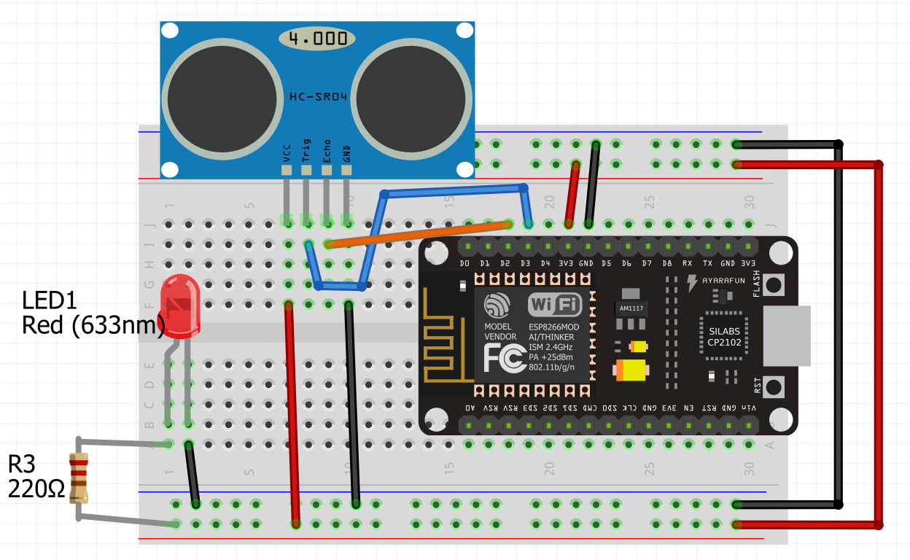

Arduino Ultrasonic Code

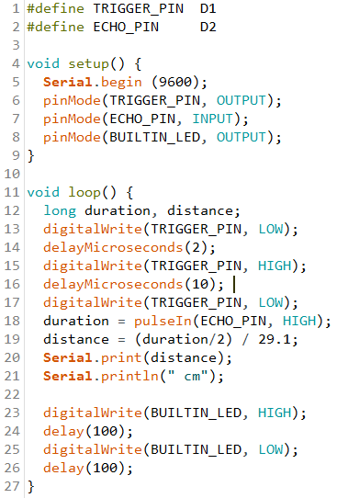

Ultrasonic demo WinForm App

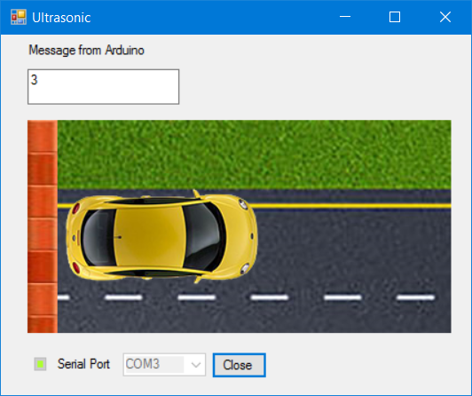

Sound

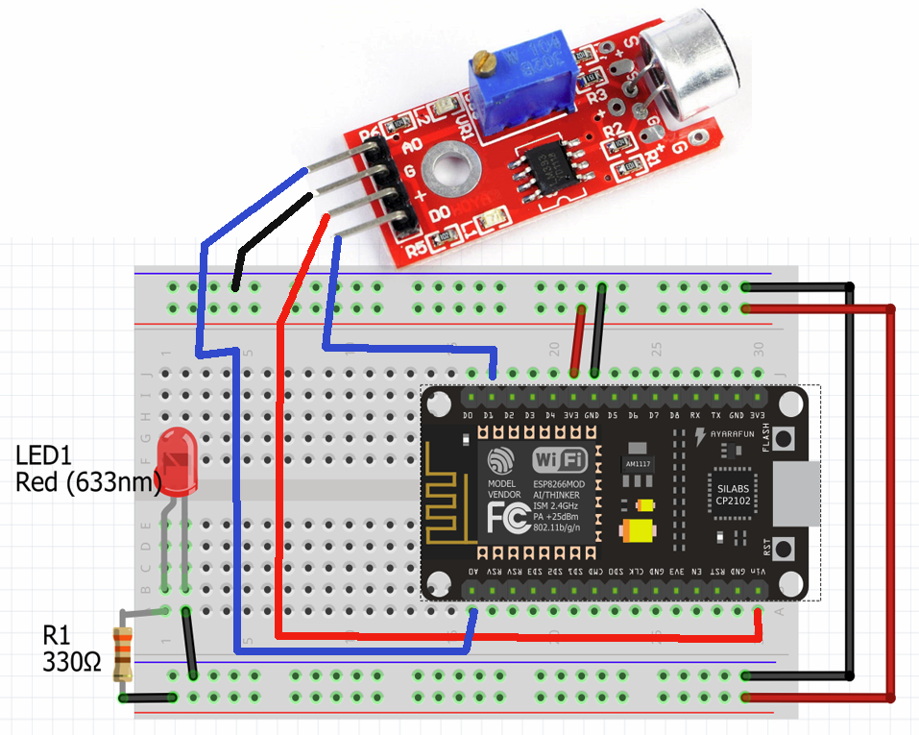

Arduino Sound Digital mode

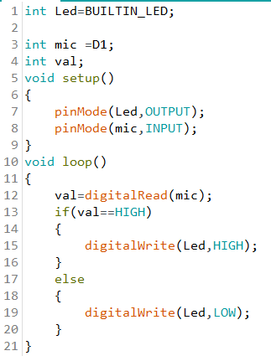

Arduino Sound Analog mode

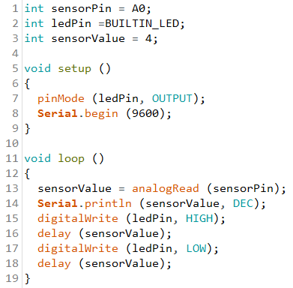

WinForm Sound Sensor

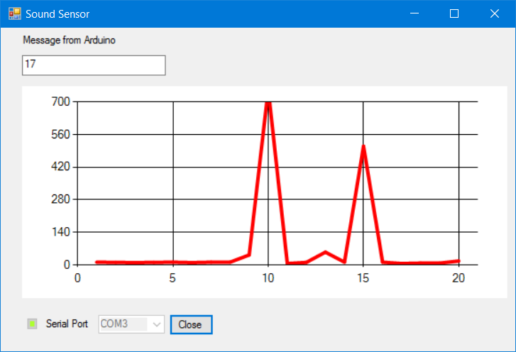

Potentiometer

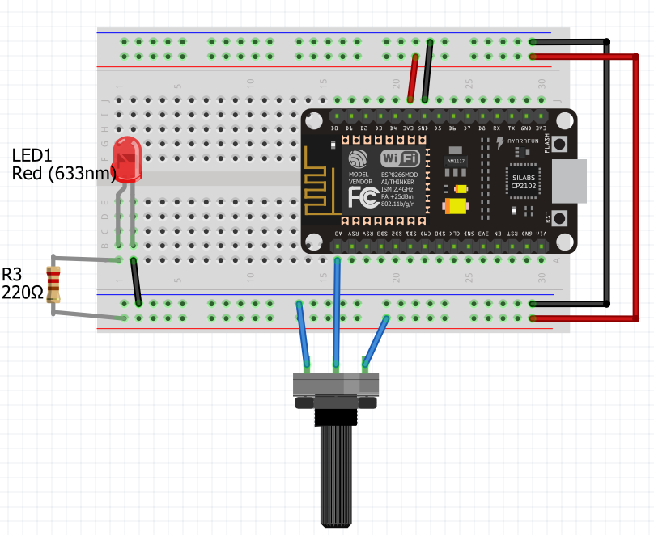

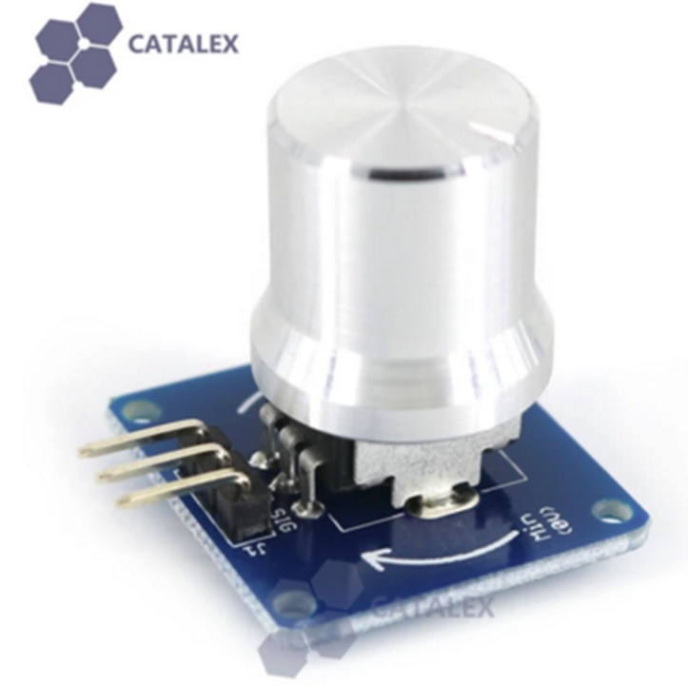

Potentiometer

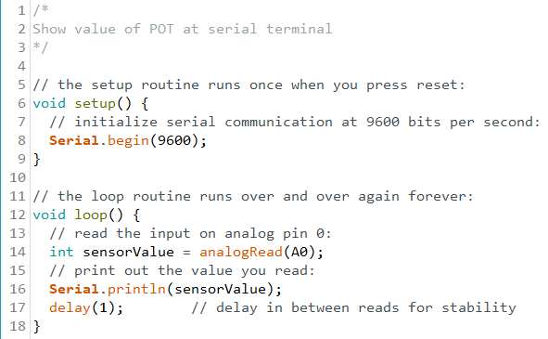

Potentiometer

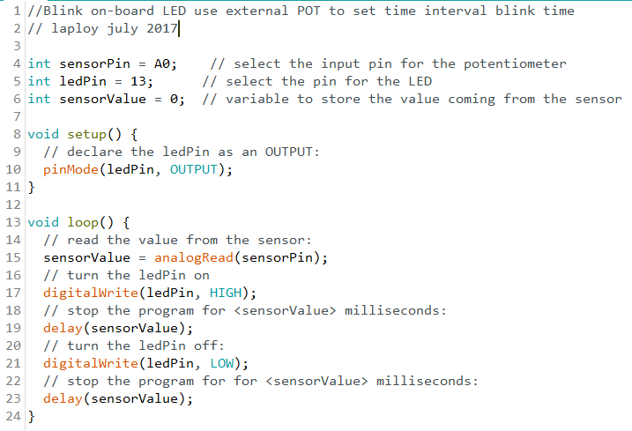

Potentiometer

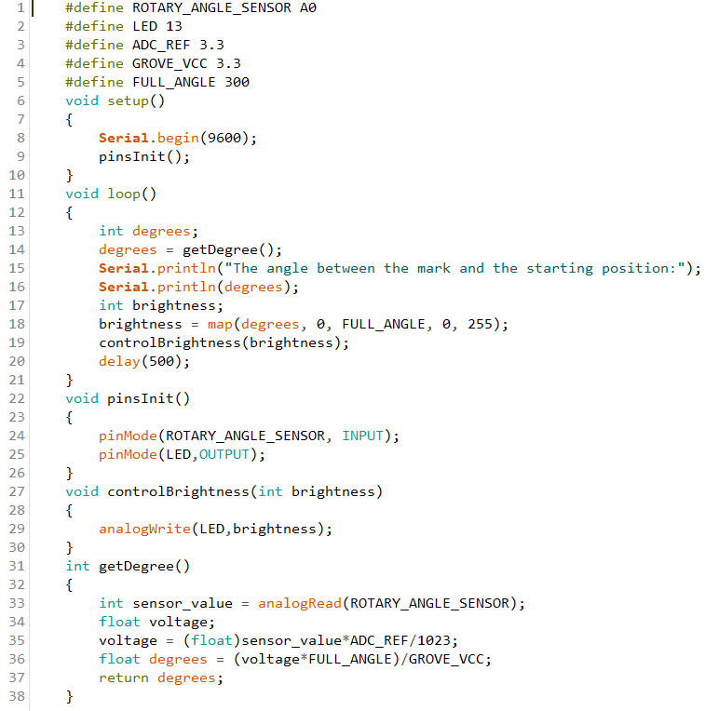

Device to Cloud

1. Create Device Sim
2. Run sim and check with Device monitor
3. Modify sim to send real data

Sending message to Cloud

* Send message from device to IoT Hub
* IoT Hub is Microsoft Azure endpoint
* IoT hub always use AMQPS protocol
* Sending messages using Microsoft Azure Service Bus

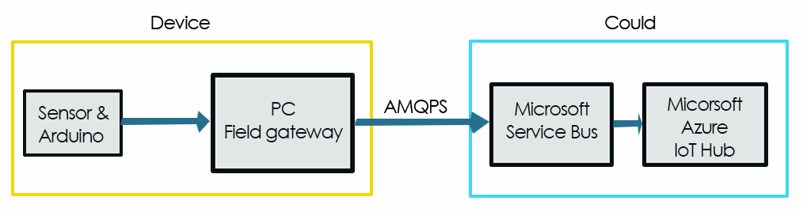

Create Sim device

1. Create new C# WinForm
2. Add Text box “textBoxD2C” and “textBoxSensorData”
3. NuGet Package Manager install WindowsAzure.ServiceBus
4. Add Code

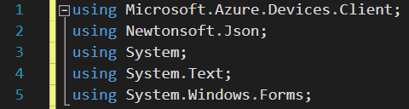

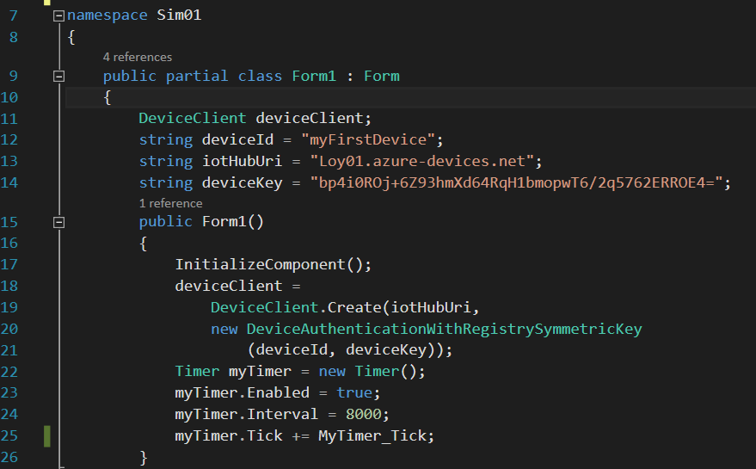

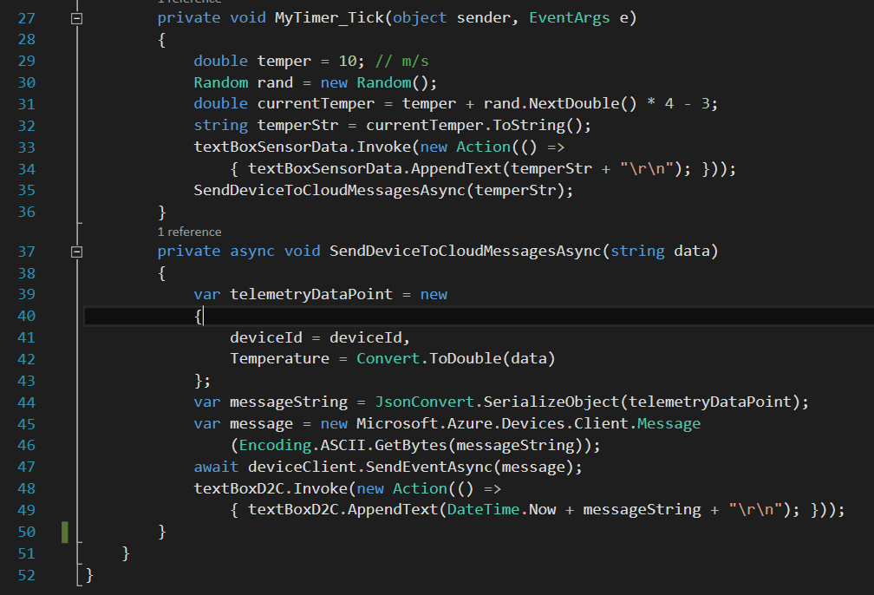

1. Run program
2. Open Device Explorer / Data / Monitor

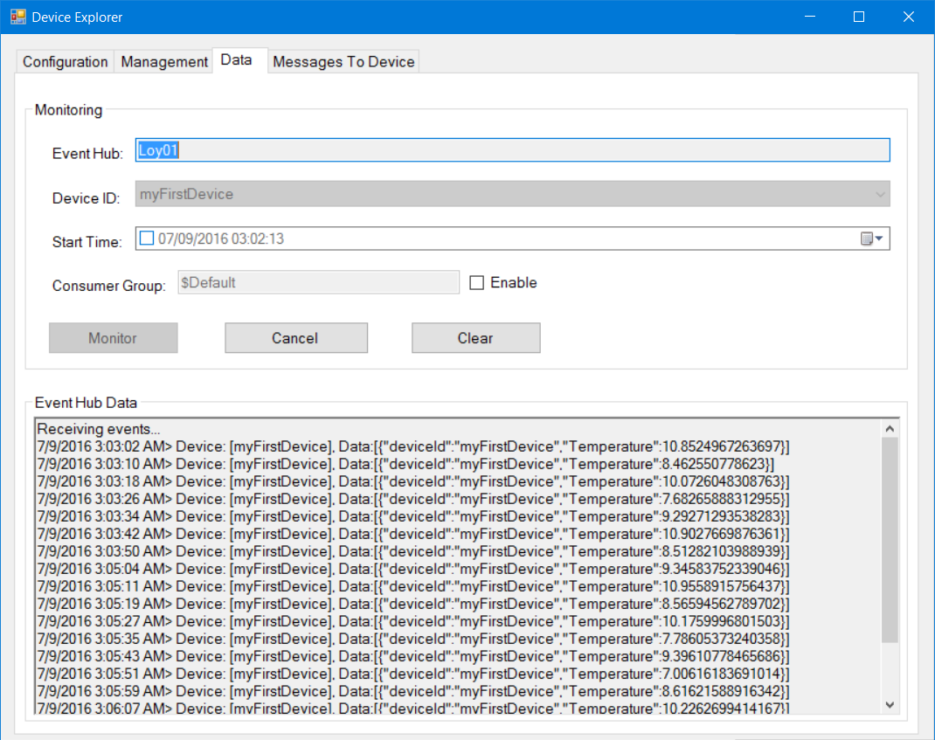

Create real D2C C# Winapp

1. Copy sim solution
2. Add reference to LoySerialPortUserControl
3. Add LoySerialPortUserControl to Form1
4. Remove Timer and edit Form1 code

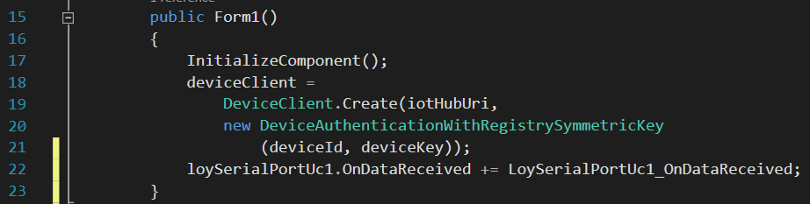

1. Edit code in LoySerialPortUc1_OnDataReceived

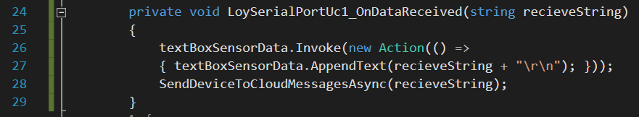

1. Build Temperature hardware
2. Write Arduino Temperature program, delay =1000
3. Upload Arduino code
4. Run real D2C Winapp
5. Watch result in device monitor

D2C Lab

1. Send Ultra Sonic data to Cloud
2. Send Sim and Real data to Cloud concurrently